Ideation Phase
Empathize & Discover

Date | 08-12-2025
Team ID
Project Name | Book a Doctor
Maximum Marks | 4 Marks

Empathy Map Canvas:
Understand the needs, frustrations, and behaviors of Users(patients)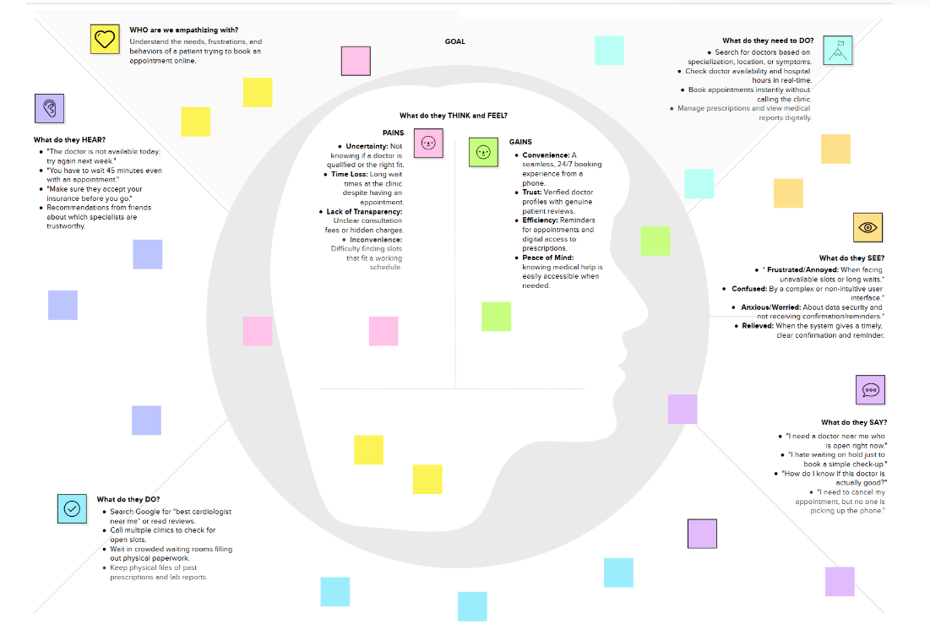seeking consistent work through a platform like Book a doctor.

Reference: https://www.mural.co/templates/empathy-map-canvas

